**Junaid Girkar**

**60004190057**

**TE COMPS A4**

**Experiment No 9**

**Aim:** To process spatial and temporal data.

**Theory:**

**Spatial Databases**

Spatial data is associated with geographic locations such as cities,towns etc. A spatial database is optimized to store and query data representing objects. These are the objects which are defined in a geometric space.

## **Characteristics of Spatial Database**

A spatial database system has the following characteristics

* It is a database system
* It offers spatial data types (SDTs) in its data model and query language.
* It supports spatial data types in its implementation, providing at least spatial indexing and efficient algorithms for spatial join.

## **Example**

A road map is a visualization of geographic information. A road map is a 2-dimensional object which contains points, lines, and polygons that can represent cities, roads, and political boundaries such as states or provinces.

In general, spatial data can be of two types −

* Vector data: This data is represented as discrete points, lines and polygons
* Rastor data: This data is represented as a matrix of square cells.

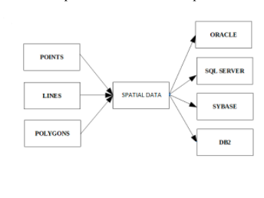

**Temporal Databases**

A Temporal Database is a database with built-in support for handling time sensitive data. Usually, databases store information only about the current state, and not about past states. For example in an employee database if the address or salary of a particular person changes, the database gets updated, the old value is no longer there. However for many applications, it is important to maintain the past or historical values and the time at which the data was updated. That is, the knowledge of evolution is required. That is where temporal databases are useful. It stores information about the past, present and future. Any data that is time dependent is called the temporal data and these are stored in temporal databases.

Temporal Databases store information about states of the real world across time. Temporal Database is a database with built-in support for handling data involving time. It stores information relating to past, present and future time of all events.

## Temporal Aspects

There are two different aspects of time in temporal databases.

* Valid Time: Time period during which a fact is true in the real world, provided to the system.
* Transaction Time: Time period during which a fact is stored in the database, based on transaction serialization order and is the timestamp generated automatically by the system.

## Temporal Relation

Temporal Relation is one where each tuple has associated time; either valid time or transaction time or both associated with it.

* Uni-Temporal Relations: Has one axis of time, either Valid Time or Transaction Time.
* Bi-Temporal Relations: Has both axes of time – Valid time and Transaction time. It includes Valid Start Time, Valid End Time, Transaction Start Time, Transaction End Time.

Code and Output:

Part-1: Finding nearby location of a coordinate in mongo

1. **Inserting the data**



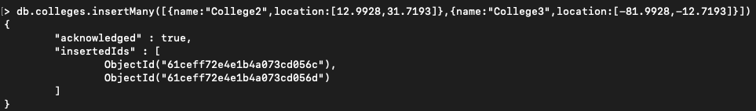

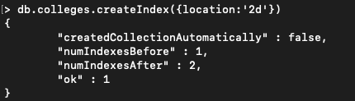

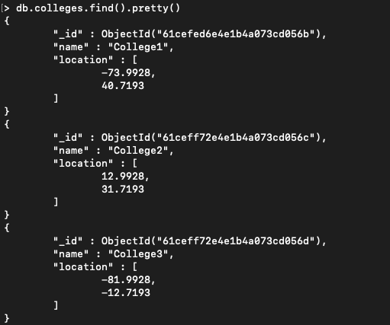

1. **Finding nearby locations using minDistance and maxDistance**

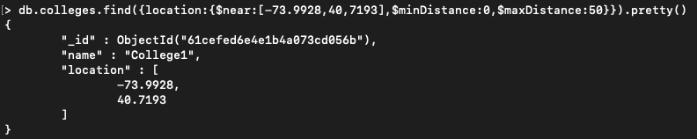

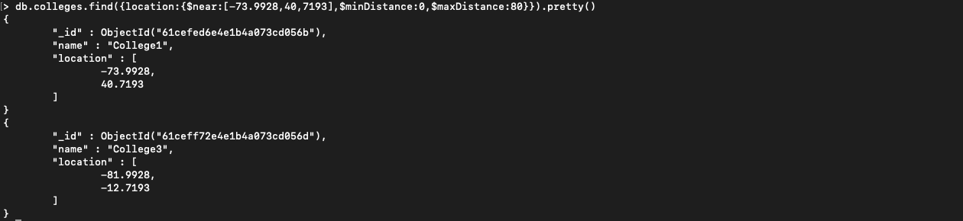

**Part-2: Querying a spatial and temporal database**

1. **Data**

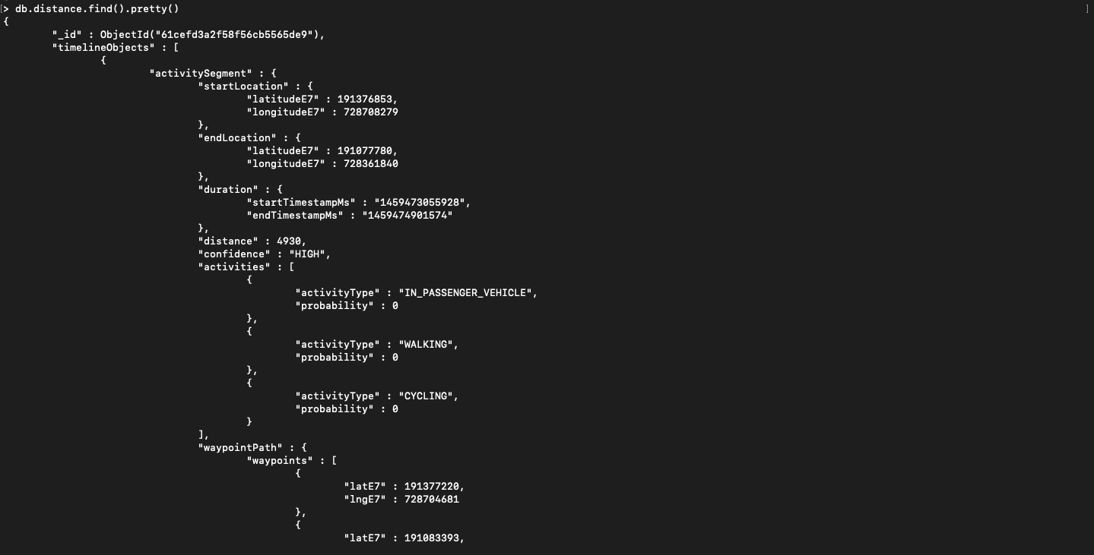

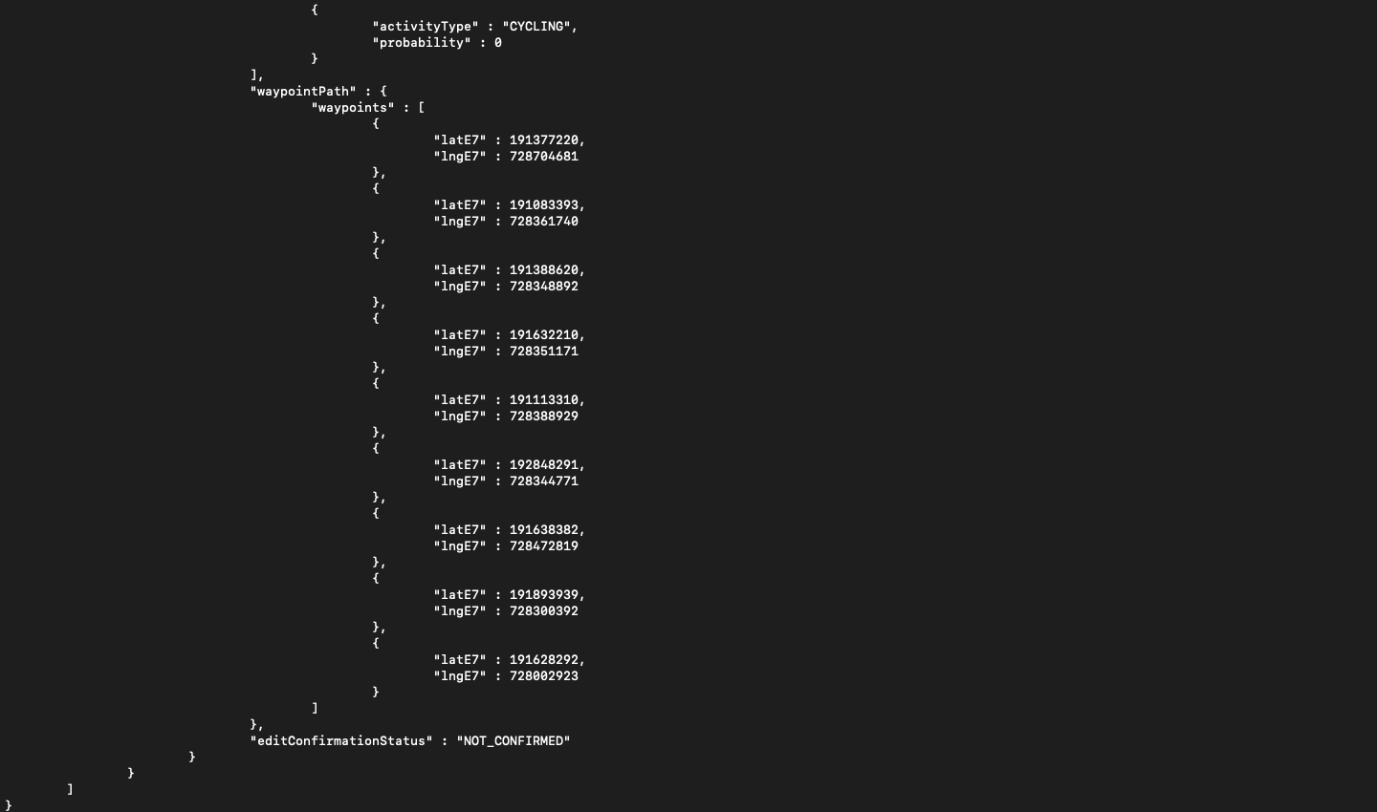

1. **Get duration**

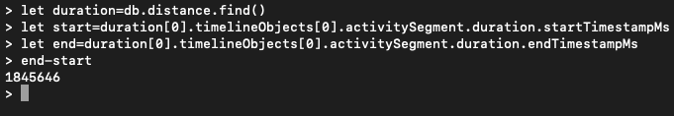

1. **Get distance**



**Conclusion:**

We found distance between different locations using their coordinates and learnt how we query spatial and temporal databases.